Methodology Revision Assignment - Setting up a class and then an assignment and then a second submission opportunity with TurnitinUK Originality Checker
This methodology allows students to have one go at generating an originality report for a submission and then one opportunity to change and resubmit without seeing an originality report for that final submission.

Note: in this instance you will actually create two assignments and the second one will be linked to the first.

Step 1: Going to the TurnitinUK Site
- Open the internet browser (e.g. Windows Explorer or Firefox)
- Enter the url www.TurnitinUK.com into the browser address field.

Step 2: Logging In
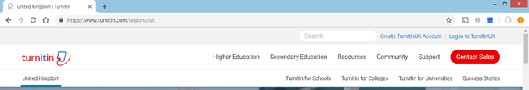
- Ensure that the location is English (United Kingdom). Choose Log In

Figure 1: TurnitinUK Home Page
- Enter your QUB email address and password (your password is the one you entered when creating your profile).

Step 3: Setting up a ‘Class’
(Note: within TurnitinUK ‘class’ equates to a module within the University)

- Once you have logged in your instructor homepage will appear (see Figure 2)

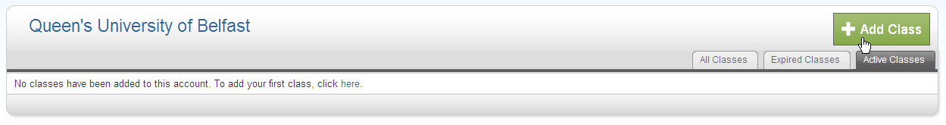
Figure 2: Instructor Homepage
- Click on the ‘Add Class’ button to create a new class. A new screen will appear (see Figure 3 overleaf)
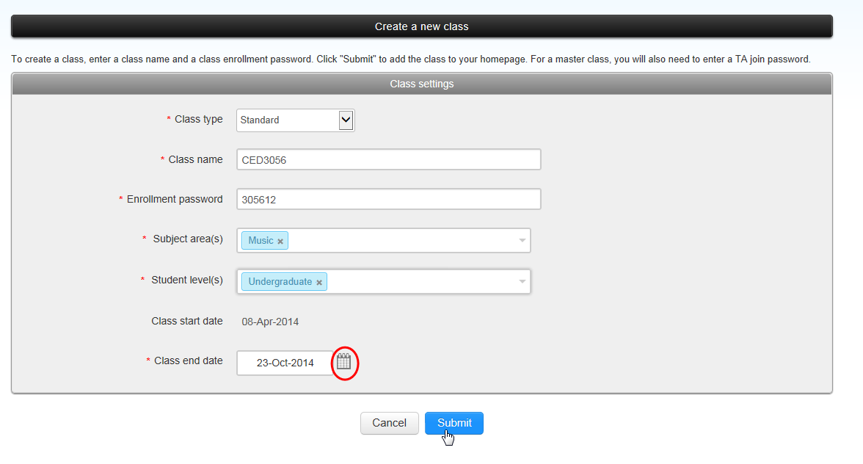
Please choose the closest area to your discipline
Figure 3: Create a New Class
- In the ‘Create a New Class’ screen the following details must be entered:
  - The class type must be selected as ‘Standard’.
  - Enter a class name of your own choosing (which should be meaningful to the student, e.g. the name of the module).
  - Enter an enrolment password (bearing in mind that you will be issuing this to your students).
  - Enter the subject area
  - Enter the student level
Note: Make a note of the password to give to the students later
- Enter a class end date by typing in the information or by clicking the calendar beside the date.
Note: This should be approximately two months later than the end of the module
- Click Submit.
- A new window will appear with the acknowledgement that you have created a new class and a unique class ID will be automatically allocated.
Note: If you are using Firefox it will be necessary to allow popups from the site. Make a note of the class ID and enrolment password to give to the students later. Click on continue to close this screen. You can also retrieve the class ID from the instructor homepage.
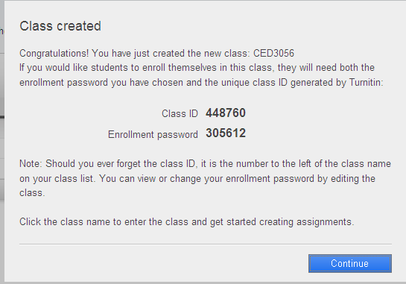
Figure 4: Confirmation Screen of Successful Creation of Class
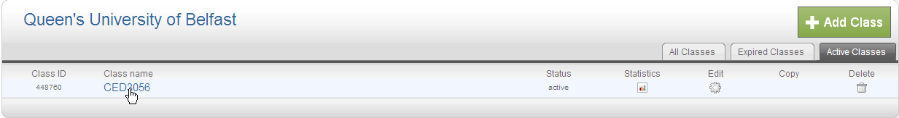
- Once you have closed the notification window you will be brought to your instructor homepage which now contains the ‘class’ or module you have created. Click on the name of the class that you have just created.

Figure 5: Instructor Homepage
Step 4: Creating an assignment
- This will bring you to the homepage for that class or module. You will need to click the ‘Add Assignment’ button.
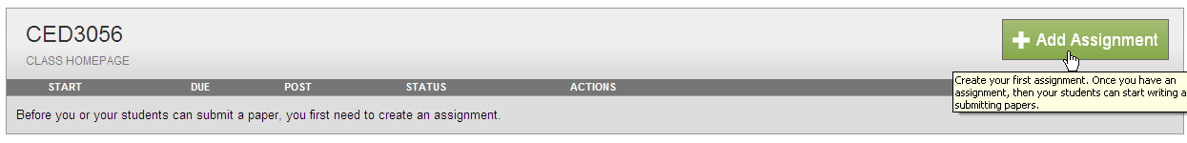
Figure 6: Add Assignment Button
- The next screen that appears will be the ‘new assignment’ page. Add an assignment title which is clearly identifiable for students.
- Select a start date when the assignment will be made available to view by the student by selecting from the drop down menu.
- Select a due date from the drop down menu.
- Open the ‘Optional settings’ button at the bottom of the page.
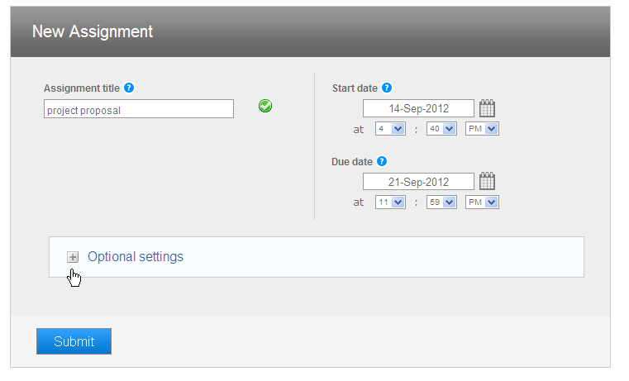
Figure 7: New Assignment Page - Assignment names and dates
- Additional options will now be displayed and you should set them as displayed in the following figure. This will enable you to create an assignment whereby the student can only upload their assignment once up to and beyond the due date and allow them to view the originality report.
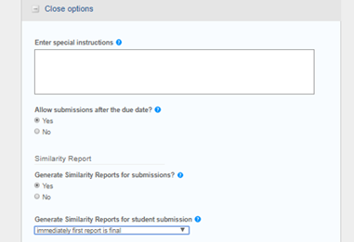
Figure 8a: New Assignments Page – Options 1
- The next set of options relate to what is shown on the originality report. You may exclude bibliographic and quoted materials as well as small matches but you are advised to include them and then exclude them later using the filter facility. Allow submissions after the due date, in case you need to grant any extensions.
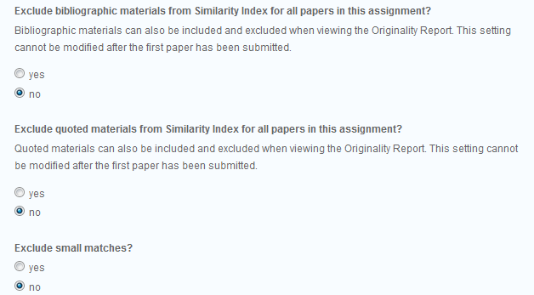
Figure 8b: New Assignment Page - Options 2
- Allow the students to see the originality reports so that they can see where they might be considered to have “lifted text”.
- Choose whether marking is anonymous or not ( if you are giving formative feedback it may not actually be practical).
- Submit the papers to the repository so that they can be used as a basis for future comparisons.
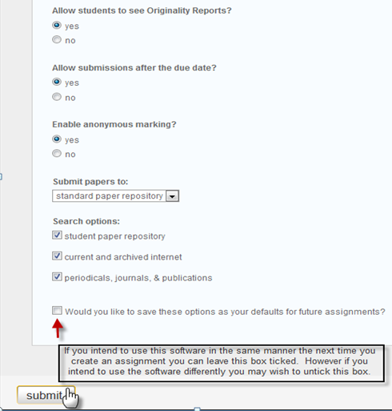
Figure 8c: New Assignment Page - Option 3
- Click ‘submit’ at the bottom of the screen
- You will now see your new assignment displayed within your class

Step 5: Creating the revision assignment
- Click the ‘Add assignment’ link again.
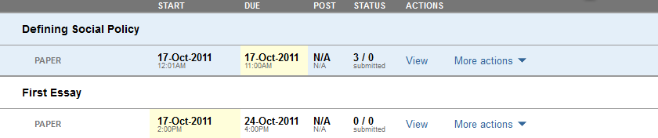
Figure 9: Class Homepage
- Select ‘revision assignment’ from the new assignment screen.
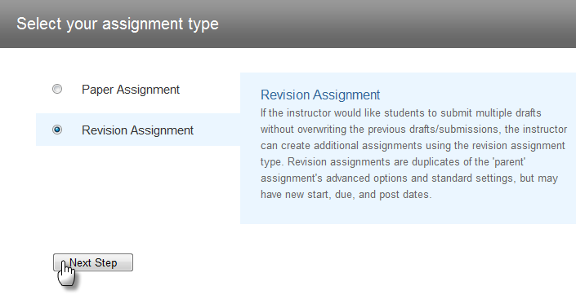
Figure 10: Assignment Type
- Select the assignment you made previously from the based on paper assignment droop down menu.
- Adjust any of the dates if required.
- Select to generate originality reports on due date.
- Choose ‘no’ from the ‘allow students to see originality reports menu.
- Click submit.
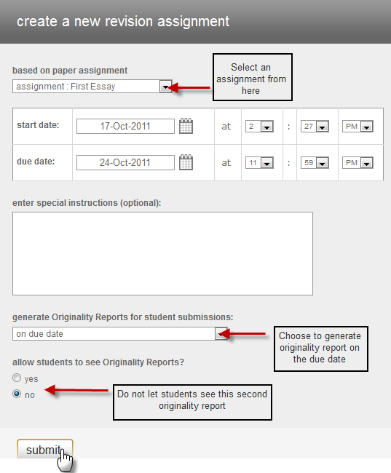
Figure 11: Create a new revision assignment Screen
- You will now see your revision assignment displayed within your class underneath the original assignment.

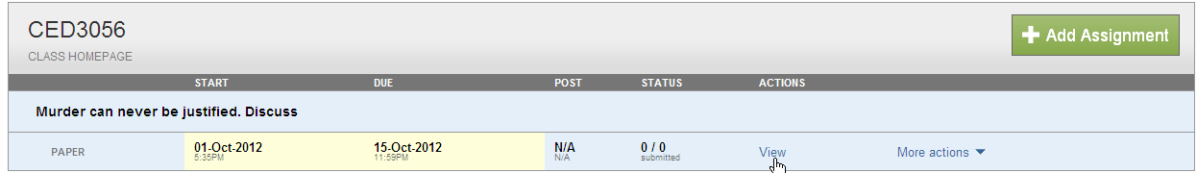

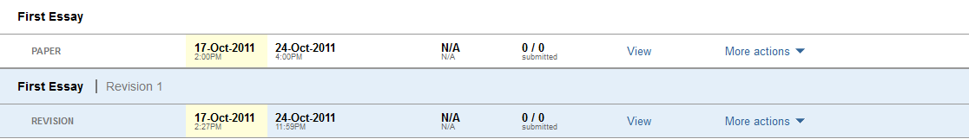
Figure 12: Class Homepage
Note: Revision assignments are always named ‘Revision 1’ and ‘Revision 2’ by default.

Step 6 Viewing the inbox
- When you go to your class homepage your assignments will be displayed. Click on the ‘view’ button to view the inbox for that assignment.
Figure 13: Class Homepage
- Future student submissions to this assignment will appear in the inbox.
- You will need to email all of the students in the class and provide them with the ‘class ID’ and the ‘enrolment password’ that you created for the module. They will need these to enrol in the module and submit their assignment(s) that you have created.

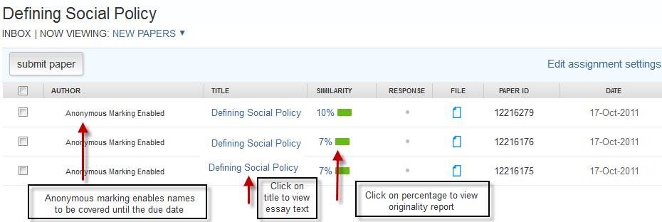
Figure 14: Class Inbox
NOTE: You are reminded that for copyright and data protection reasons you should not enrol students and upload their assignments yourself unless your school has collected written permission from the students.

