Methodology Invisible to Student: Student submits once, does not view report
These instructions provide step by step guidance on how to set up a class with TurnitinUK Originality Checker and then an assignment where the student submits their assignment once but does not gain access to view the originality report.

Step 1: Going to the TurnitinUK Site
- Open the internet browser (e.g. Windows Explorer or Firefox)
- Enter the url www.TurnitinUK.com into the browser address field.

Step 2: Logging In
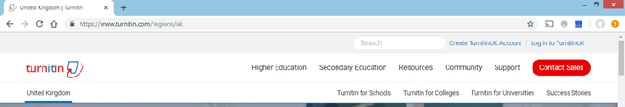
- Ensure that the location is English (United Kingdom). Choose Log In

Figure 1: TurnitinUK Home Page
- Enter your QUB email address and password (your password is the one you entered when creating your profile).
Step 3: Setting up a ‘Class’
(Note: within TurnitinUK ‘class’ equates to a module within the University)
- Once you have logged in your instructor homepage will appear (see Figure 2)
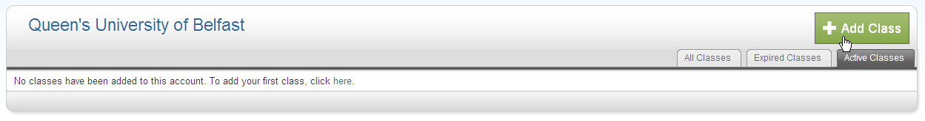
Figure 2: Instructor Homepage
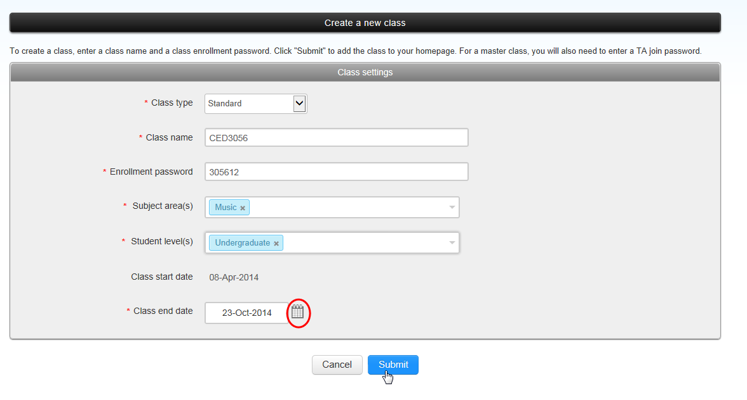
Figure 3: Create a New Class
- In the ‘Create a New Class’ screen the following details must be entered:
  - The class type must be selected as ‘Standard’.
  - Enter a class name of your own choosing (which should be meaningful to the student, e.g. the name of the module).
  - Enter an enrolment password (bearing in mind that you will be issuing this to your students).
  - Enter the subject area
  - Enter the student level
Note: Make a note of the password to give to the students later
- Enter a class end date by typing in the information or by clicking the calendar beside the date.
Note: This should be approximately two months later than the end of the module
- Click Submit.

- A new window will appear with the acknowledgement that you have created a new class and a unique class ID will be automatically allocated.
(Note: If you are using Firefox it will be necessary to allow popups from the site). Make a note of the class ID and enrolment password to give to the students later. Click on continue to close this screen. You can also retrieve the class ID from the instructor homepage.
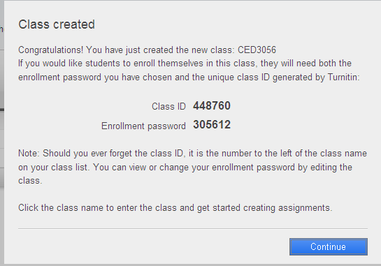
Figure 4: Confirmation Screen of Successful Creation of Class
.
Figure 2: Instructor Homepage
Once you have closed the notification window, you will be brought to your instructor homepage which now contains the ‘class’ or module you have created. Click on the name of the class that you have just created.
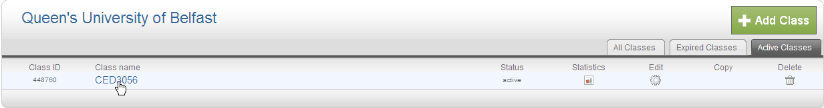
Figure 5: Instructor Homepage

Step 4: Creating an assignment
- This will bring you to the homepage for that class or module. You will need to click the ‘Add Assignment’ button.
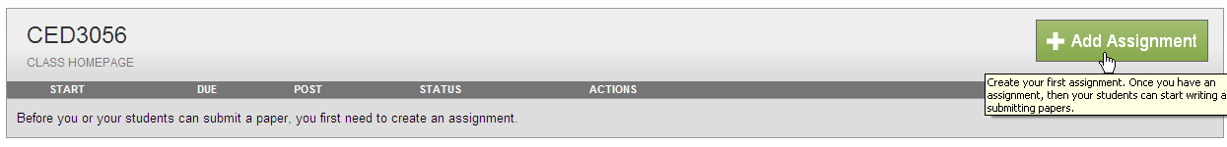
Figure 6: Add Assignment Button
- The next screen that appears will be the ‘New Assignment’ page. Add an assignment title which is clearly identifiable for students.
- Select a start date when the assignment will be made available to view and submit to by students by selecting from the drop down menu.
- Select a due date from the drop down menu.
- Open the ‘Optional Settings’ button at the bottom of the page.
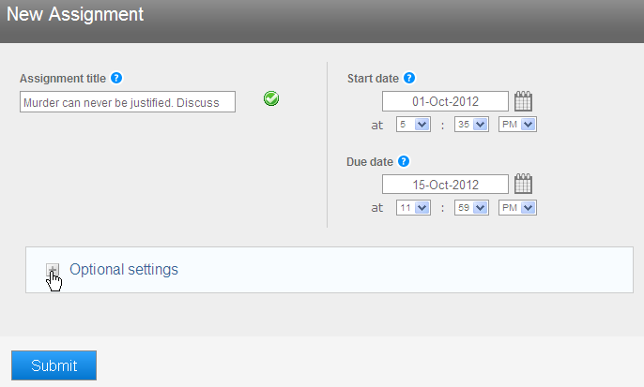
Figure 7 New Assignment Page - Assignment names and dates

- Additional options will now be displayed below the selections you have just made and you should set them as displayed in the following figure. This will enable you to create an assignment whereby the student can upload their assignment only once. They will not be able to view the originality reports.

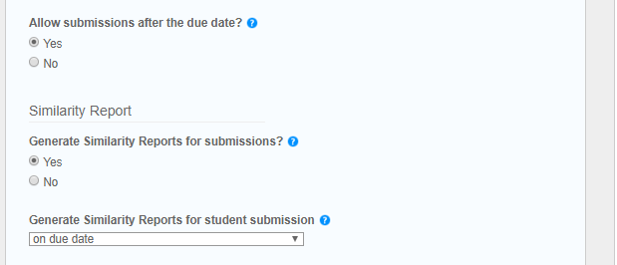
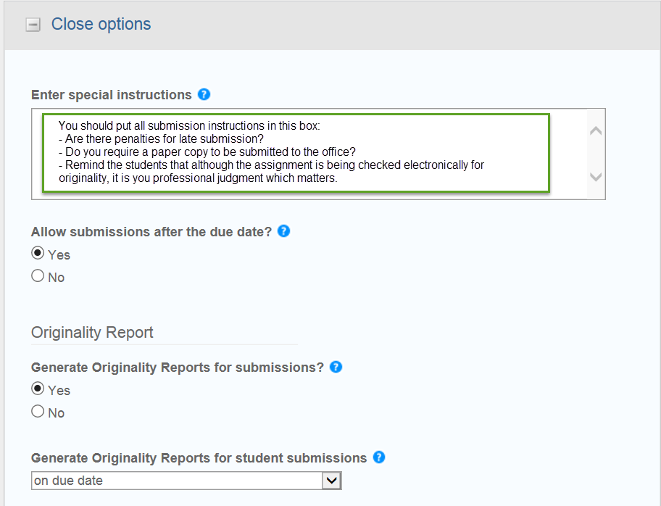
Figure 8: New Assignments Page - Options
- The next set of options relate to what is shown on the originality report. You are advised not to exclude bibliography, quoted materials or small matches.
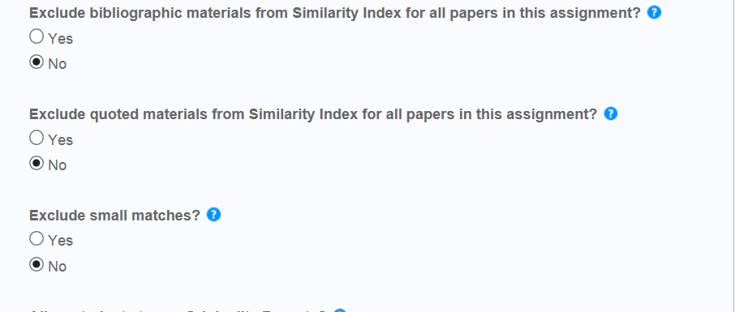
Figure 9: New Assignment Page - Options part 2
- Click ‘no’ so students are not able to see the originality reports.
- Click ‘yes’ to allow submissions after the due date, in case you need to grant any extensions.
- Click ‘no’ to disable anonymous marking.
- Submit the papers to the repository so that they can be used as a basis for future comparison.
- If this is going to be the standard methodology for all assignments you create in the future, select that you would like to save these options as your defaults for future assignments. You will always have the opportunity to change these defaults at a later stage.
- Click ‘Submit’ at the bottom of the screen.
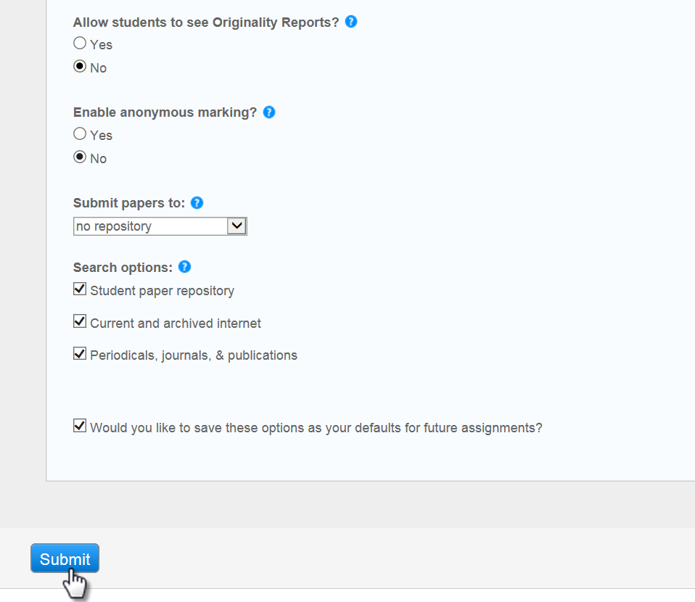
Figure 9: New Assignment Page - Options part 3
- You will now see your new assignment displayed within your class.

Step 5: Viewing the inbox
- When you go to your class homepage your assignments will be displayed. Click on the ‘view’ button to view the inbox for that assignment.
Figure 3: Class Homepage
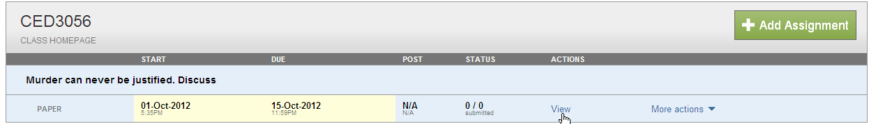
Figure 10: Class Homepage
- Future student submissions to this assignment will appear in the inbox.
- If you require the students to enrol themselves, you will need to email all of the students in the class and provide them with the ‘class ID’ and the ‘enrolment password’ that you created for the module. They will need these to enrol in the module and submit their assignment(s) that you have created.
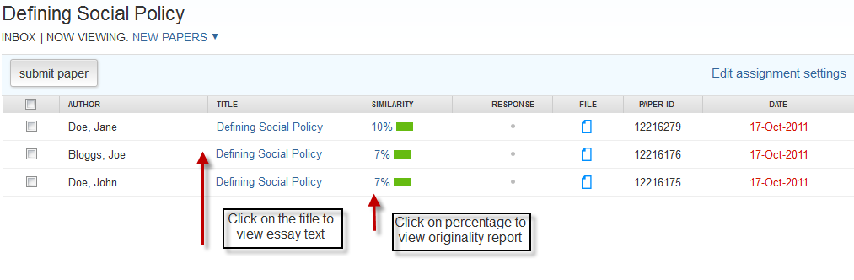
Figure 11: Class Page Inbox

Note: You are reminded that for copyright reasons your School should have collected advance written permission from the student should you wish to upload student assignments yourself.
Step 6: Enrolling the students
In order to enrol your students in the Class you should have a Word, Excel, or plain text file of Student: Forename, Last Name and Queen’s email address. This information is available from the QSIS system. You should have a note of the file’s location as you will be asked to browse for it as part of the upload process.
n. b. Students are required to use their Queen’s email as a username in Turnitin as these are the only accounts which Queen’s can verify. You should not accept submissions from other email addresses.
- When you go to your class homepage click on the Students tab.
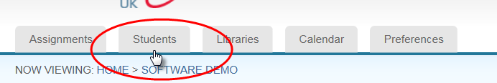
Figure 12: The Students Tab

- Click on the Upload Student List button.

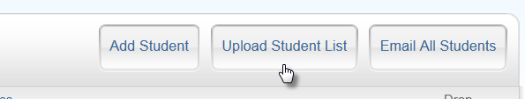
Figure 13: The Upload Student List button
- Browse for your student list file
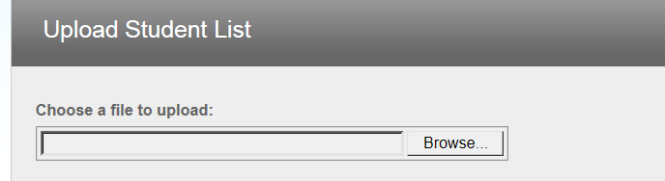
Figure 14: Browsing for the student list file
- Once you have selected the file, click on Upload List.

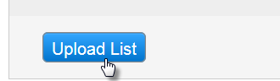
Figure 15: the Upload list button

- You will be asked to confirm that the data is correct – check that you have the name data in the correct fields.

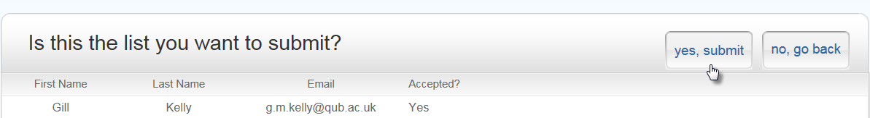

Figure 16: Confirm submission data
- Your upload will be confirmed. The students will receive an email to confirm that they have been enrolled in your class.

If this is the students’ first use of Turnitin they will need to complete their registration. The Student Instructions for Setting up Your Account from Your Welcome Email will take them through this process step by step. You are advised to download these instructions for the CED Turnitin website and make them available to your students.

