

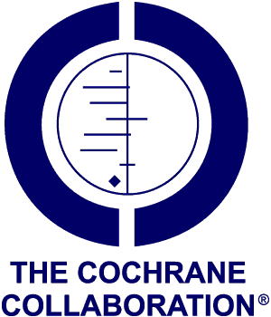


Eleventh Annual Cochrane in Ireland Conference: From Idea to Impact

Riddel Hall, Queen’s University Belfast
Friday 10th June 2016, 9.00-16.00

EXTENSION TO SUBMISSION DATE
Abstracts are invited for POSTERS to be displayed at the conference. Posters should address any issue related to conducting, teaching about or using systematic reviews or applying evidence to practice. They may present a Cochrane protocol or review. Abstracts of no more than 200 words must include:

- Title of the poster
- An abstract that gives the subject matter, methods and conclusions of the poster, emphasising its relevance for evidence-based practice
- Name and title of presenter(s)
- Institutional affiliation, contact address, phone number and email address

The best poster will receive an award based on methodology and relevance to clinical practice. The award is generously provided by the Health Research Board.
Abstracts are to be submitted electronically to j.mcgaughey@qub.ac.uk by 5pm Friday 20th May 2016. Abstracts will be peer-reviewed and decisions sent to all applicants by Wednesday 25th May 2016.

Details about Plenary Presentations will be available from April at:
http://ireland.cochrane.org/ and the All Ireland Cochrane Conference 2016 website
The websites above will have further details and registration forms available in mid-May 2016, but in the interim you can register your interest to attend with Jennifer McGaughey
j.mcgaughey@qub.ac.uk

